
Student Name: Omare Levi
Admission Number: BSCCS/2024/56230
Course/Class: Computer Science
Unit Code: BIT4138
Unit Name: Advanced Cryptography
Lecturer Name: Micheal Nyoro
Semester/Academic Year: 3.2

Contents
WEEK 1: 4
FIG 1.1: confirms the successful installation of Python 4
FIG 1.2 : verifies the successful installation of cryptographic libraries 4
FIG 1.3 : shows the successful initialization of the GitHub repository 5
WEEK 2: Implementation of Classical Encryption Algorithms 6
FIG 2.1: shows the implementation of the Caesar Cipher algorithm 6
FIG 2.3: illustrates the Vigenère Cipher encryption process 8
WEEK 3: Implementation of Stream Cipher Systems and Random Sequence Analysis 9
FIG 3.1: shows the implementation of a Linear Feedback Shift Register 9
WEEK 4: Advanced Encryption Standard (AES) and Block Cipher Operations 12
FIG 4.1: shows the implementation of the Advanced Encryption Standard 12
FIG 4.2: demonstrates the generation of cryptographic keys 13
FIG 4.3: illustrates the encryption of a file using the AES algorithm 13
FIG 4.4: shows the results of performance testing conducted on the AES implementation 14
WEEK 5: Implementation of RSA Encryption and Key Management 15
FIG 5.1: shows the generation of an RSA public and private key pair 15
FIG 5.2: demonstrates the encryption of a message using the RSA public key 16
FIG 5.3: presents the successful decryption of encrypted data using the RSA private key. 16
FIG 5.4: Illustrates a secure communication 17
FIG 5.5: shows the results of testing and validating the RSA 17

WEEK 1: Installation and Configuration of Cryptography Development Environment
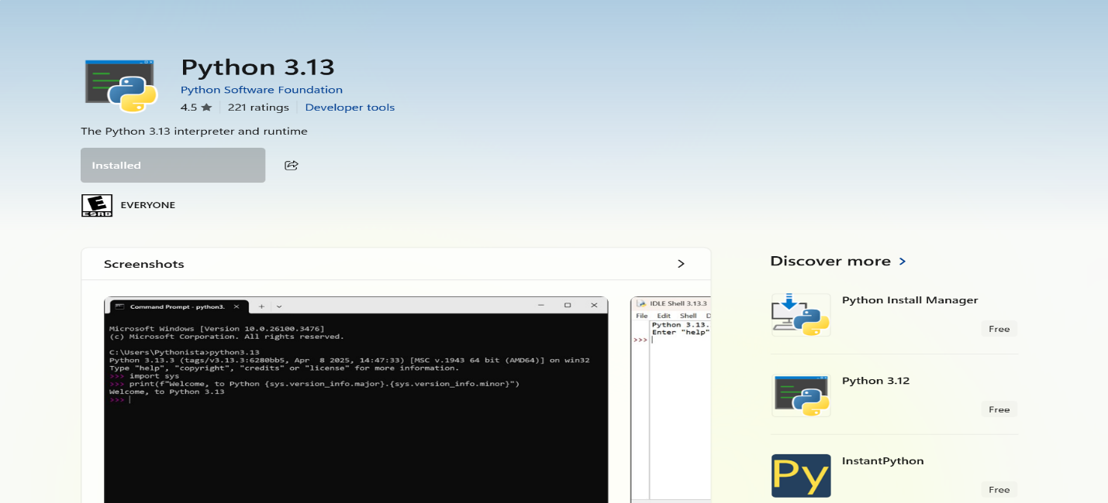
FIG 1.1: confirms the successful installation of Python , establishing the development environment required for implementing and testing cryptographic applications.
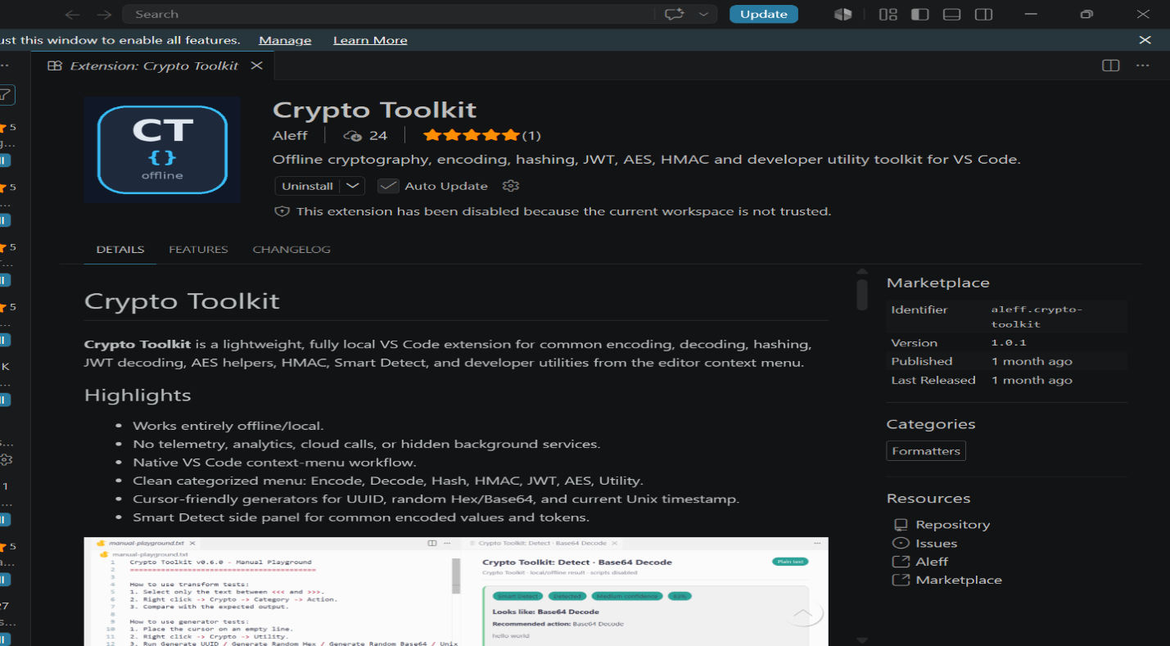
FIG 1.2 : verifies the successful installation of cryptographic libraries using the Python package manager (pip). These libraries provide encryption, decryption, hashing, and key management functions required for developing secure cryptographic solutions.
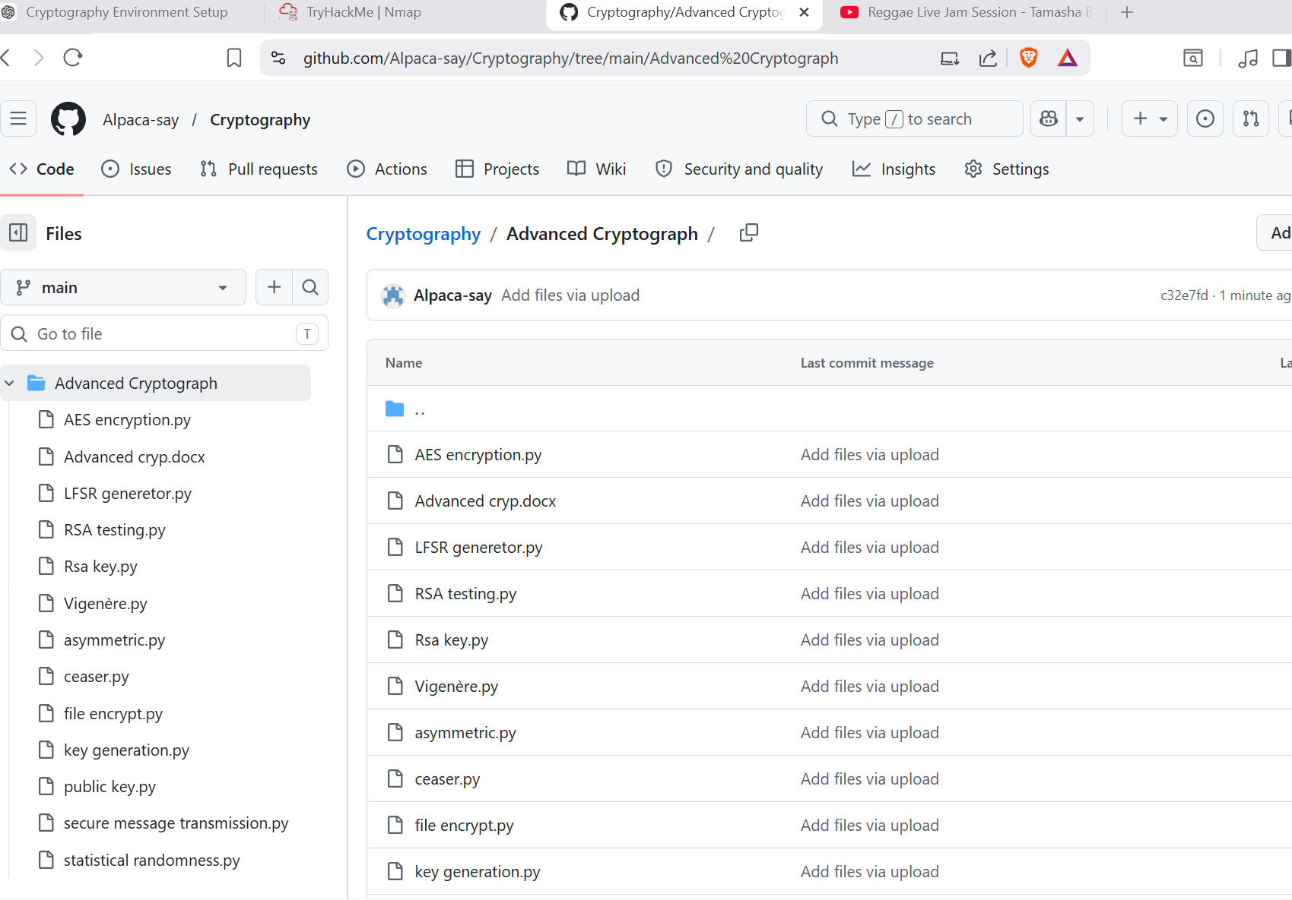
FIG 1.3 : shows the successful initialization of the GitHub repository and the first project commit. This establishes version control for tracking project changes, maintaining backups, and supporting collaborative software development practices.
The cryptography environment was successfully established by installing Python, VS Code, OpenSSL, and required libraries. An encryption script was executed successfully, and version control was set up using GitHub. The environment is now ready for implementing and testing cryptographic applications.

WEEK 2: Implementation of Classical Encryption Algorithms
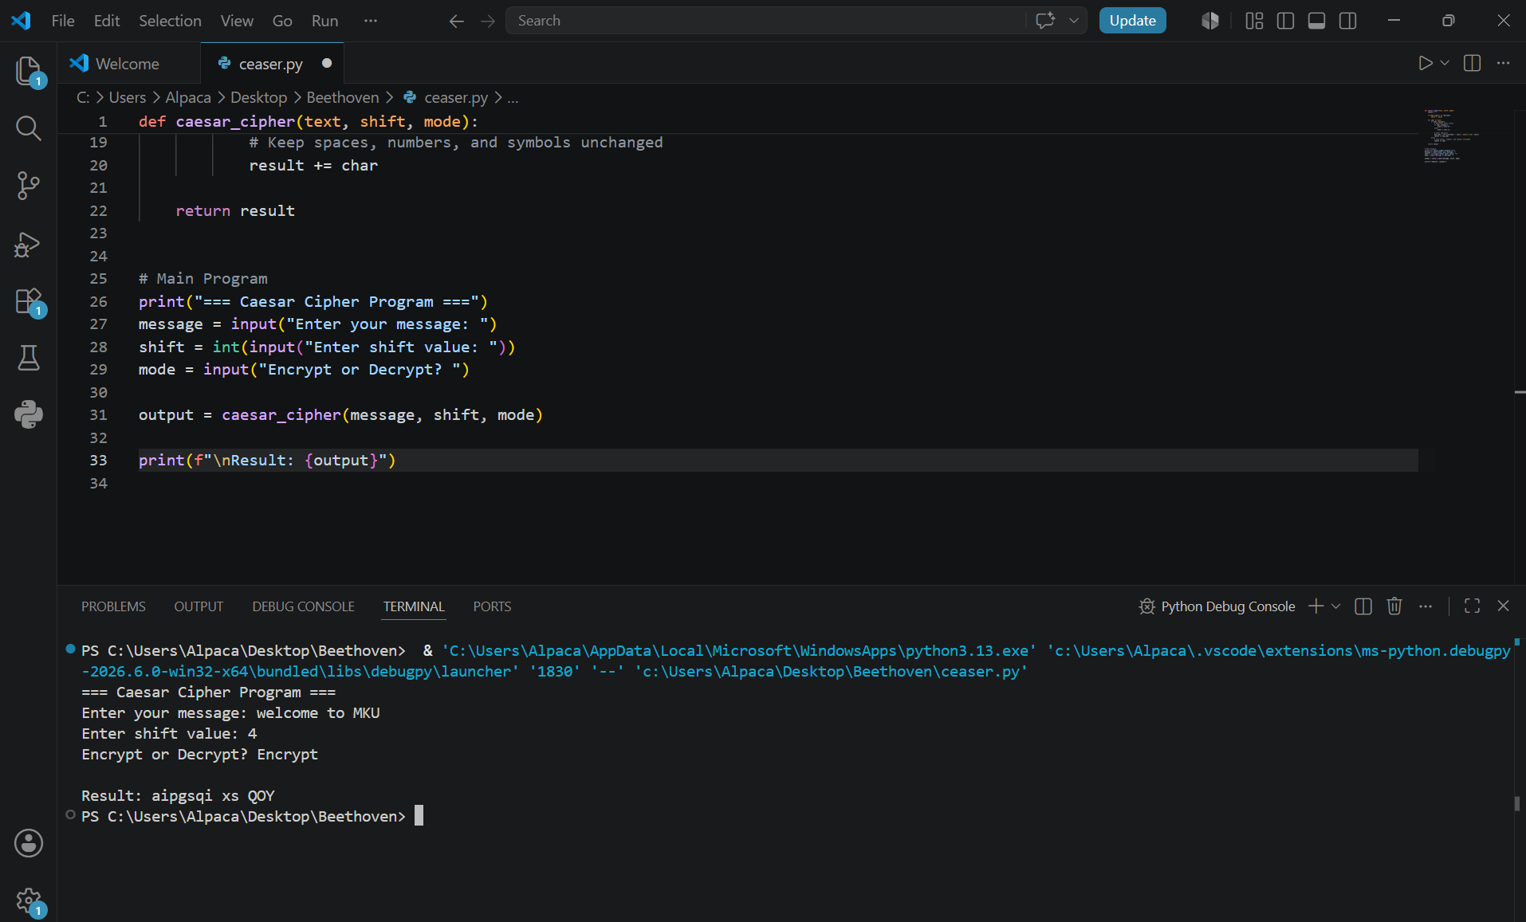
FIG 2.1: shows the implementation of the Caesar Cipher algorithm, where plaintext characters are shifted by a fixed number of positions in the alphabet. This demonstrates the basic principles of substitution-based encryption.
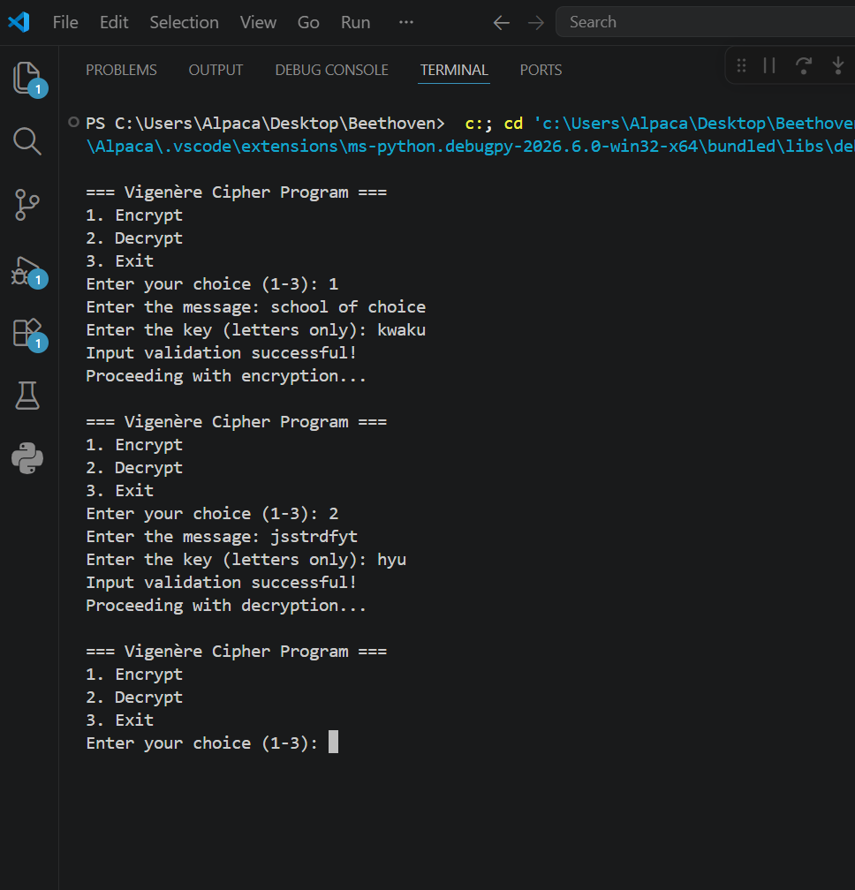FIG 2.2: demonstrates the input validation mechanism that checks user entries before processing encryption or decryption requests. This helps prevent errors caused by invalid keys, empty messages, or unsupported characters.
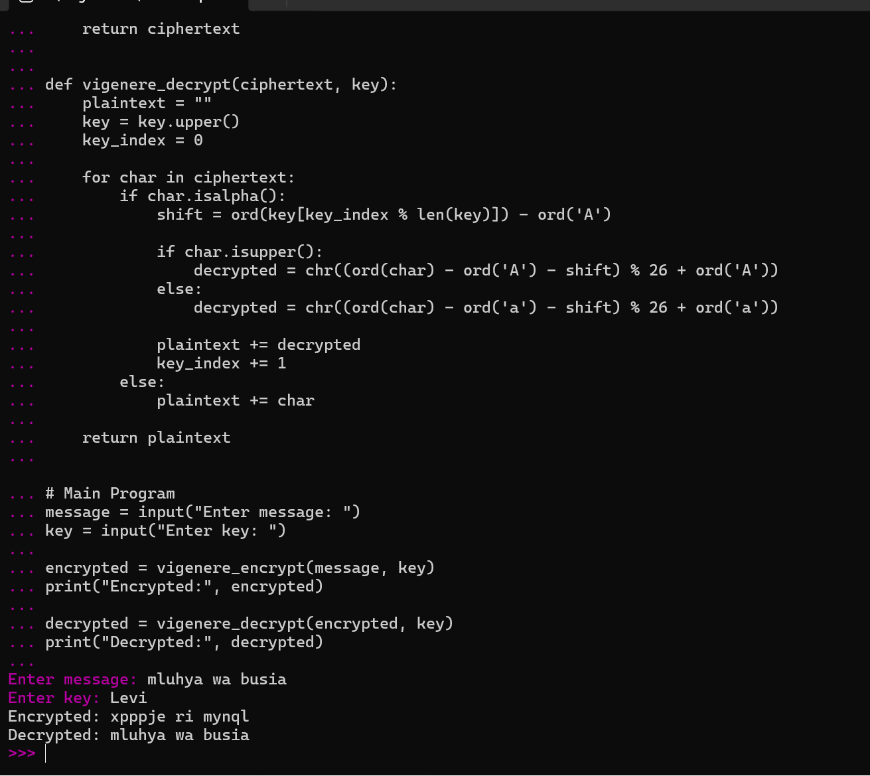
FIG 2.3: illustrates the Vigenère Cipher encryption process using a keyword to generate multiple character shifts. This polyalphabetic technique provides stronger security than a simple Caesar Cipher by reducing predictable patterns in encrypted text.

This week, I learned how classical encryption algorithms transform plaintext into ciphertext using mathematical rules and secret keys. The implementation highlighted the importance of key management in securing data. Testing revealed weaknesses such as susceptibility to frequency analysis and brute-force attacks in traditional ciphers.

WEEK 3: Implementation of Stream Cipher Systems and Random Sequence Analysis
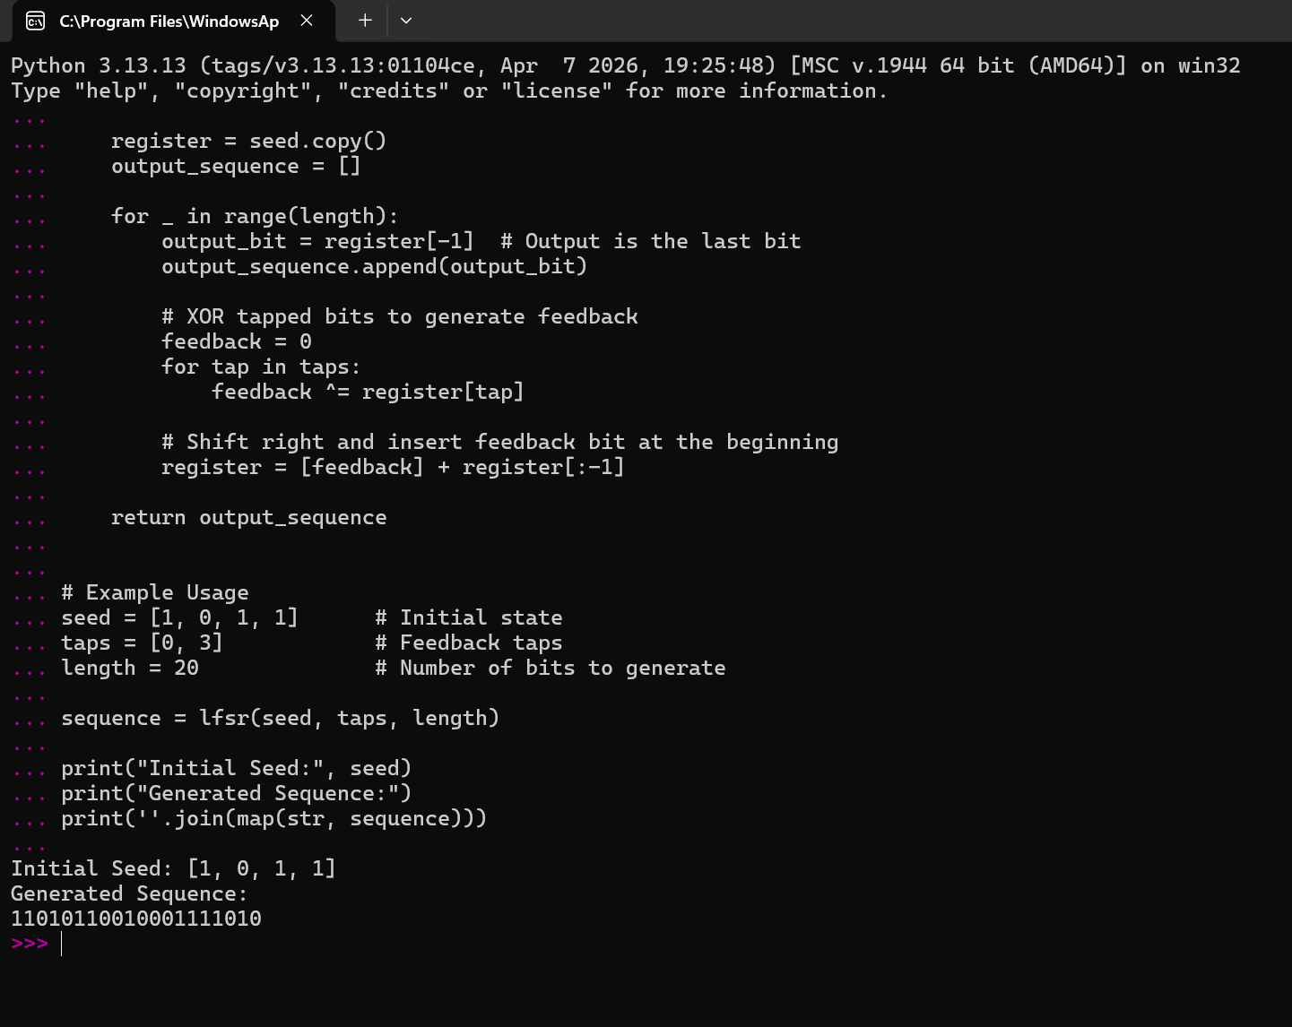
FIG 3.1: shows the implementation of a Linear Feedback Shift Register (LFSR) used to generate pseudorandom binary sequences. The generator demonstrates how mathematical feedback mechanisms can produce sequences suitable for cryptographic applications.

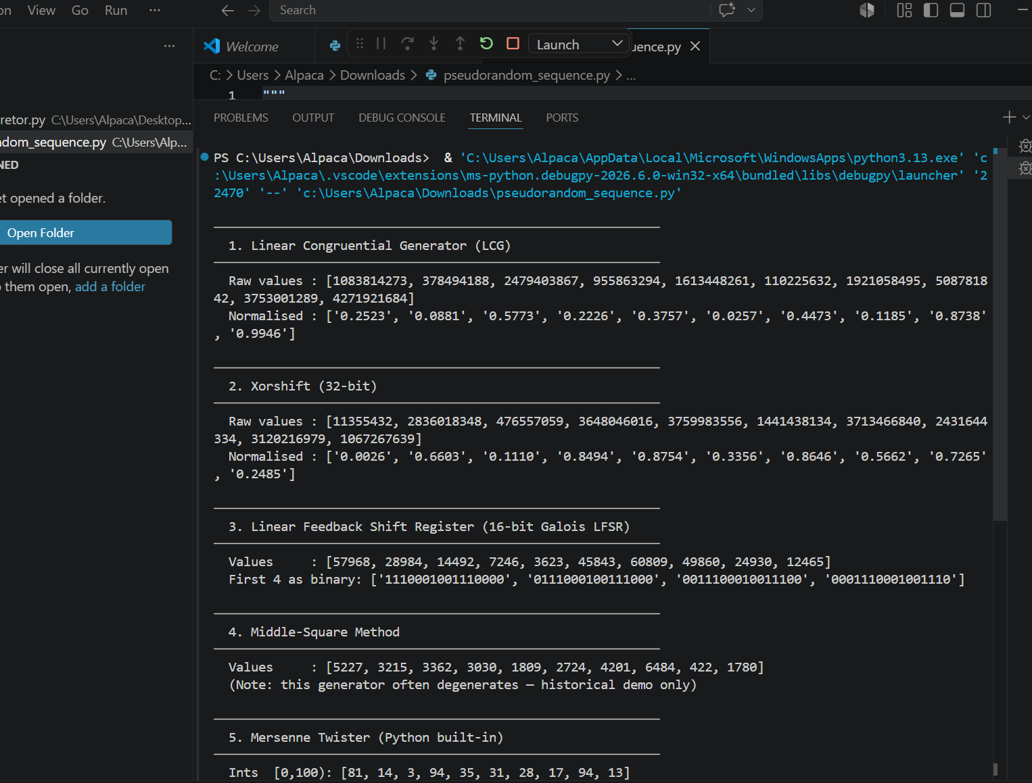FIG 3.2: displays the output produced by the pseudorandom sequence generator. The generated bit stream serves as a key component in stream cipher operations, where randomness is essential for maintaining data confidentiality.
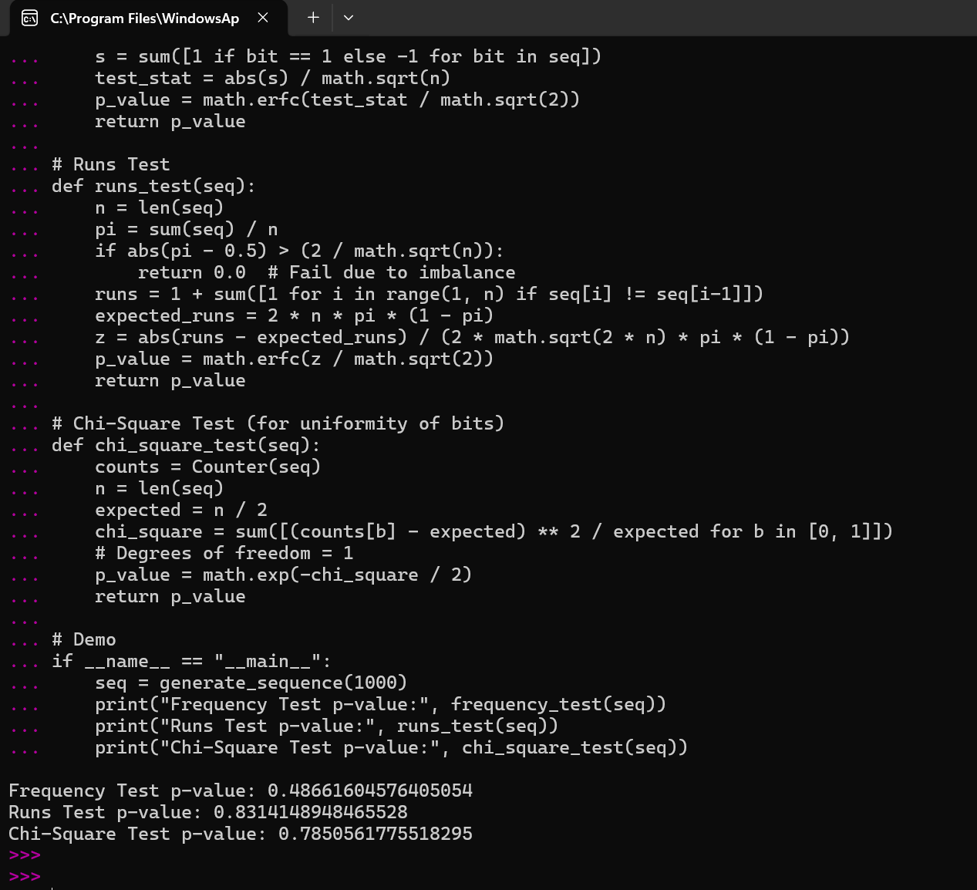FIG 3.3: presents the results of statistical tests performed on the generated sequences. These tests evaluate properties such as bit distribution and pattern occurrence to determine the quality and unpredictability of the pseudorandom output.
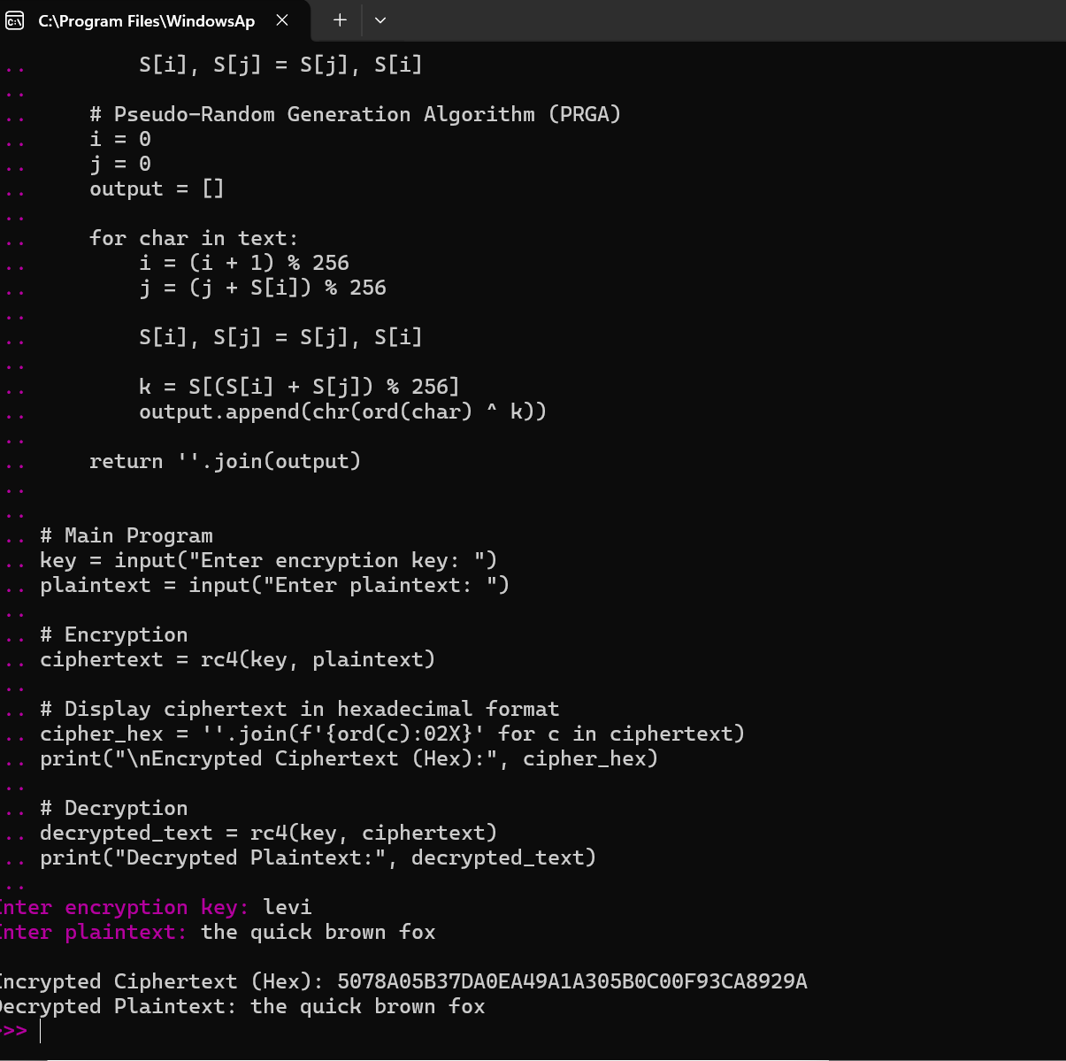FIG 3.4: Demonstrates the simulation of the RC4 stream cipher, where a keystream is generated and combined with plaintext to produce ciphertext. This illustrates the real-time encryption process used in stream cipher systems.
This week, I learned the importance of randomness in cryptography and how stream ciphers encrypt data using generated keystreams. Randomness testing helped evaluate sequence quality and security. The implementation demonstrated how pseudorandom generators contribute to secure encryption while highlighting the need for strong random sequence generation.

WEEK 4: Advanced Encryption Standard (AES) and Block Cipher Operations
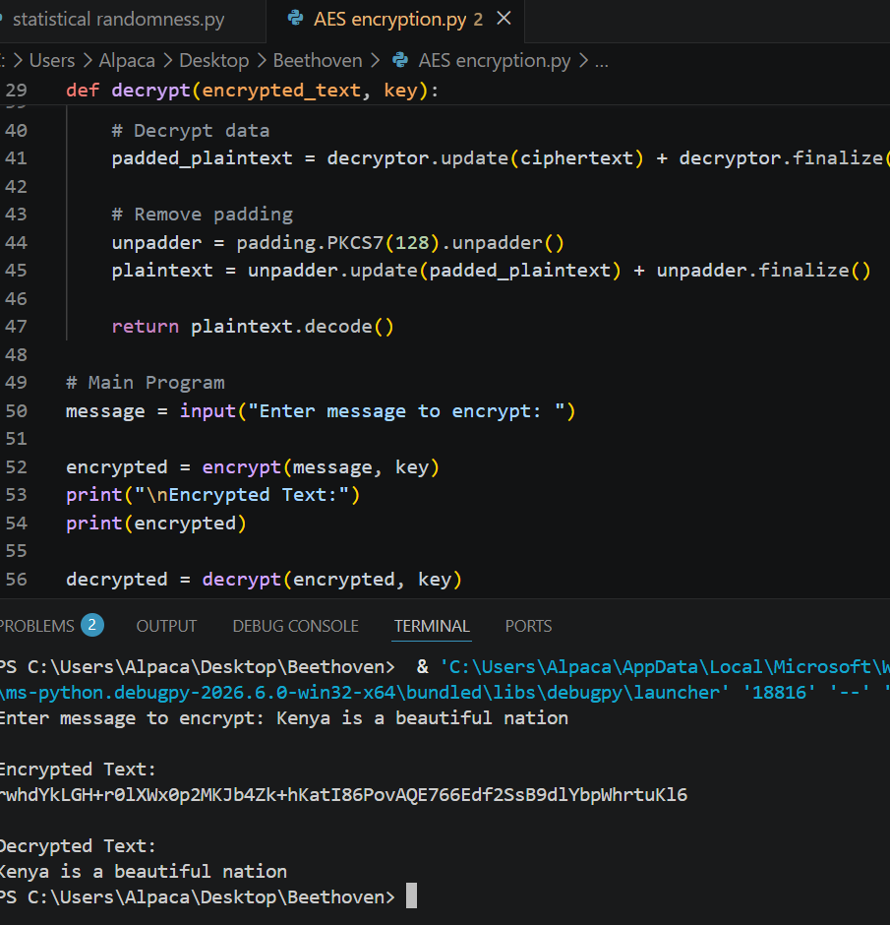
FIG 4.1: shows the implementation of the Advanced Encryption Standard (AES) encryption script. The program applies symmetric-key cryptography to transform plaintext data into secure ciphertext using a secret encryption key.

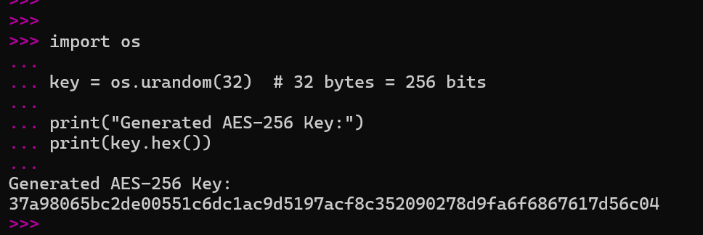
FIG 4.2: demonstrates the generation of cryptographic keys used by the AES algorithm. Secure key generation is essential because the strength of AES encryption depends heavily on the confidentiality and randomness of the generated key.
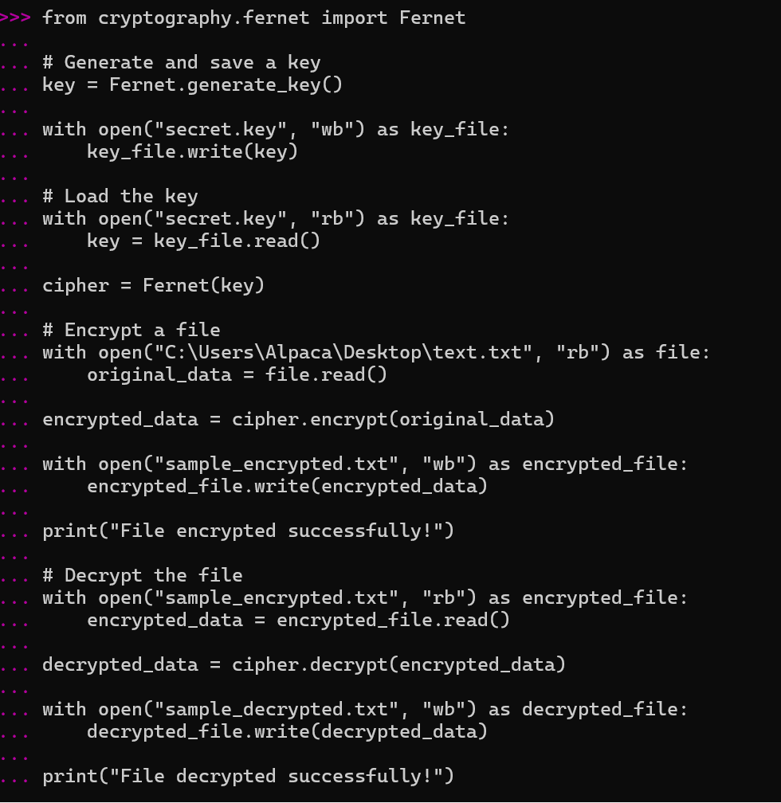
FIG 4.3: illustrates the encryption of a file using the AES algorithm. The process converts readable file contents into encrypted data, ensuring that unauthorized users cannot access the original information


FIG 4.4: shows the results of performance testing conducted on the AES implementation. The tests evaluate encryption and decryption efficiency, execution time, and the reliability of the block cipher under different conditions
This week, I learned how AES performs secure encryption and decryption using symmetric keys. The implementation emphasized the importance of protecting encryption keys, as security depends on key confidentiality. Challenges included configuring encryption parameters and handling file operations, but testing confirmed successful and reliable encryption performance.

WEEK 5: Implementation of RSA Encryption and Key Management
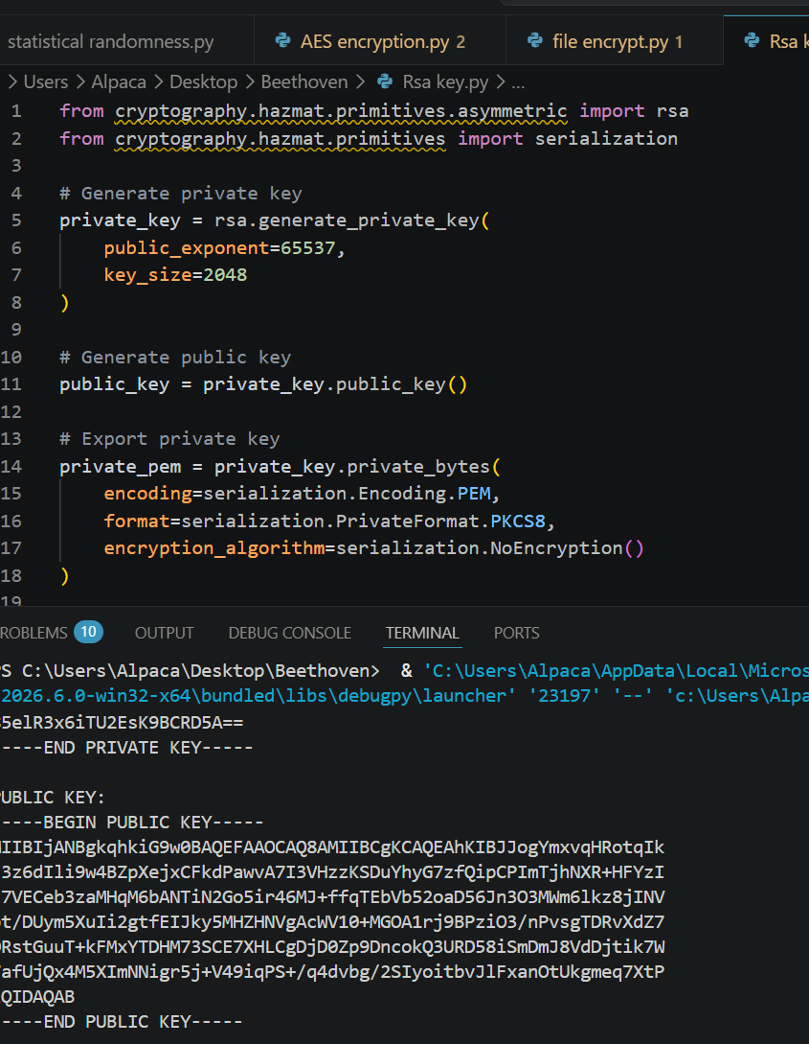
FIG 5.1: shows the generation of an RSA public and private key pair. The process creates two mathematically related keys, where the public key is used for encryption and the private key is reserved for secure decryption.

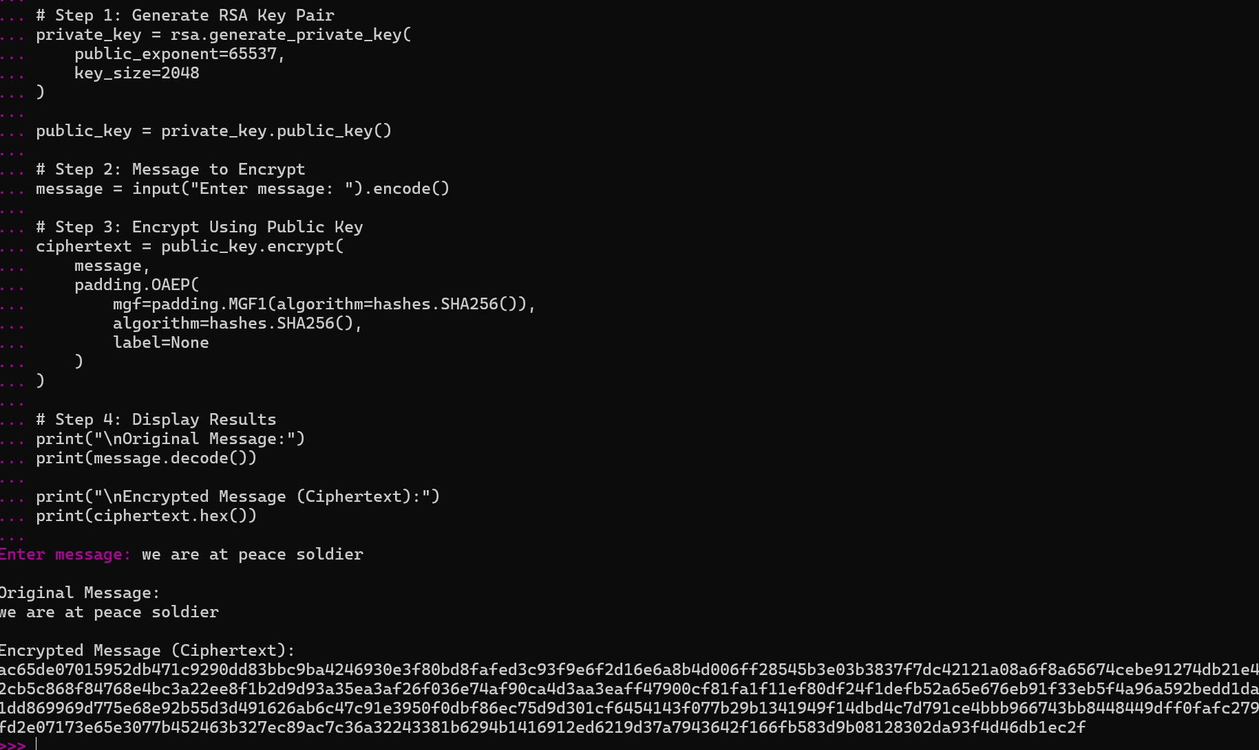
FIG 5.2: demonstrates the encryption of a message using the RSA public key. This process ensures that only the holder of the corresponding private key can decrypt and access the original information.

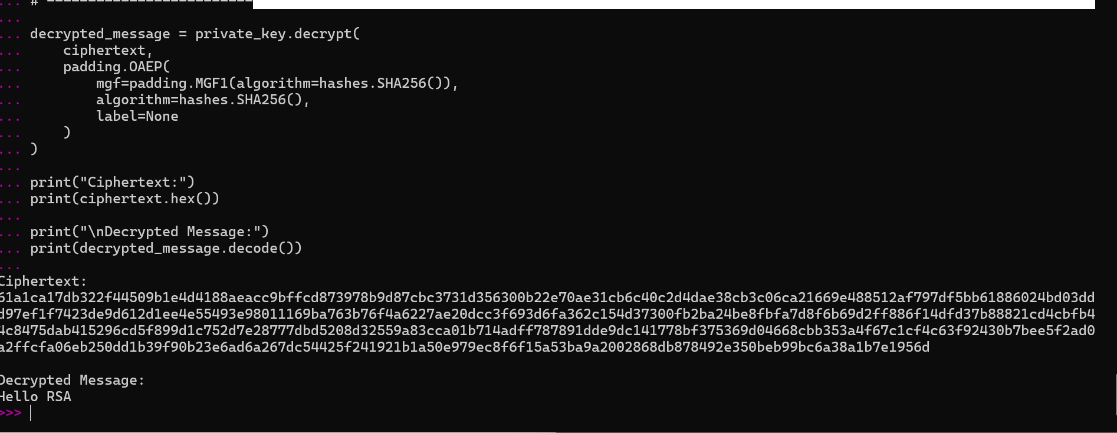
FIG 5.3: presents the successful decryption of encrypted data using the RSA private key. The output confirms the correctness of the encryption-decryption workflow and the functionality of the implemented RSA algorithm.

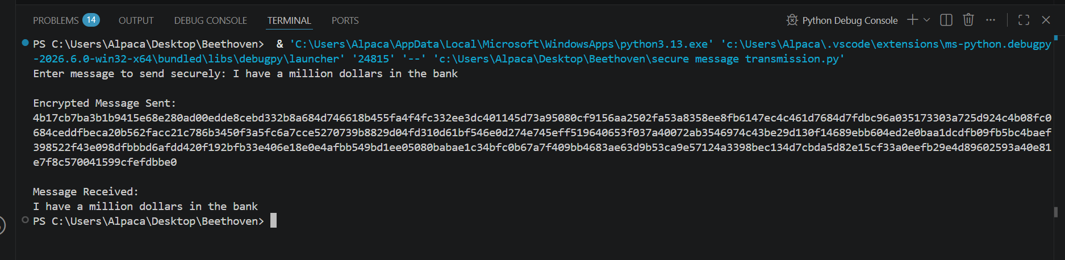
FIG 5.4: Illustrates a secure communication scenario where a message is encrypted with a public key before transmission. This ensures confidentiality during data exchange and protects information from unauthorized access.
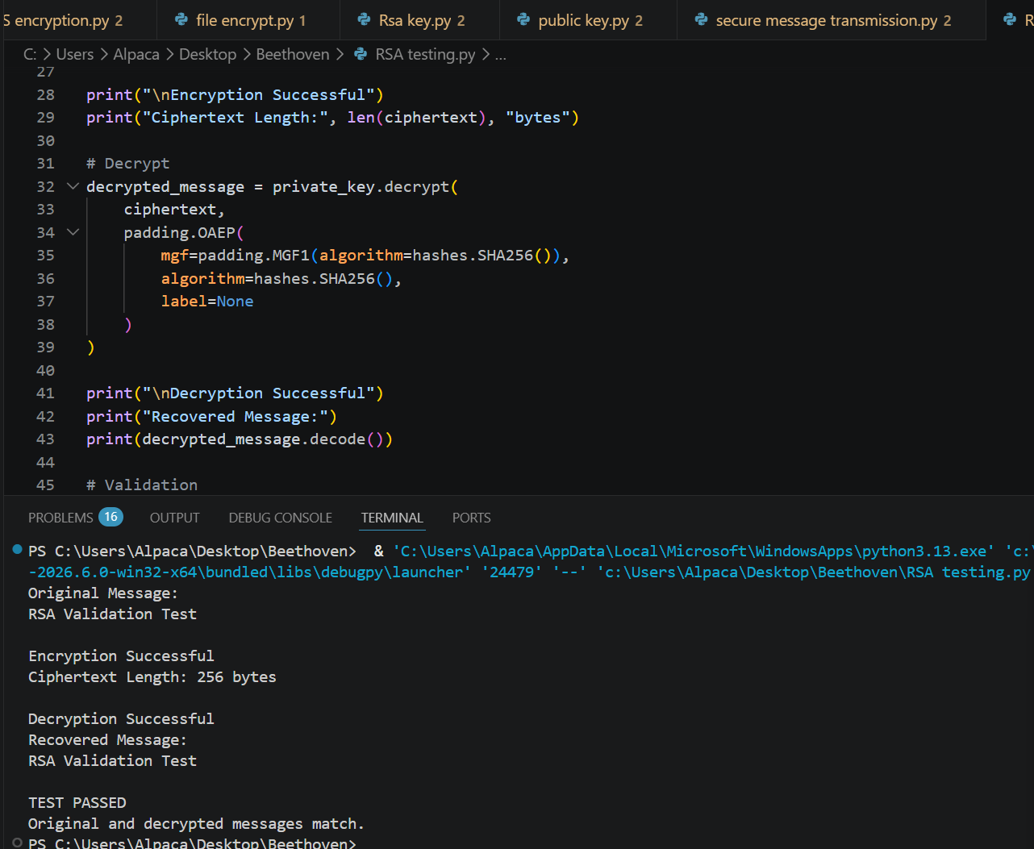
FIG 5.5: shows the results of testing and validating the RSA implementation. Various encryption and decryption operations were performed to verify accuracy, reliability, and secure key management within the system.
This week, I learned how asymmetric encryption differs from symmetric encryption by using separate public and private keys. RSA provides secure communication without sharing secret keys directly. Testing confirmed successful encryption and decryption operations, demonstrating the effectiveness of public key cryptography for protecting sensitive information.

